Your Guide to Retirement

Table of Contents

Section 1
Introduction Page 1

Section 2
Common Retirement Financial Mistakes Page 2

Section 3
Your Financial Plan Page 3

Section 4
Planning for Retirement Checklist Page 5

Section 5
Retirement Estimator Page 7

Section 6
Five Retirement Savings Tips to Help Avoid Regret Page 8

Section 7
Debt and Cash Flow Page 9
Budget Worksheet Page 10

Section 8
Nearing Retirement Checklist Page 15

Section 9
Income in Retirement Page 17

Section 10
Conclusion Page 18

Introduction

Congratulations! You have taken the first step in getting your finances in order with the goal of retiring.

At Prosperwell Financial, our mission is to coach, mentor and inspire you to achieve financial independence and happiness and we would love to help you with your investing and financial planning. In addition to helping you with your financial planning, we are here to help you with any of the following:

- A complimentary asset allocation review of any investments. You can send us your investment account statements and we will give you an analysis and our opinion at no cost.
- Analyzing your insurance such as Life, Disability and Long-Term Care Insurance. We can review your current policies or get you quotes for a new policy. We can also help you analyze the proper amount of insurance.
- Send us your Social Security statement for a Social Security Analysis.
- Establishing a college savings account for your child or grandchild.
- Setting up a 401(k), Simple IRA or SEP IRA for your business or Traditional/Roth IRA.
- Roll over your old 401(k) and consolidate your accounts so it makes it easier to manage your money.
- Charitable Giving and Donor Advised Funds.

If you have any questions about the information in this packet, would like a second opinion on your investments or would like to start planning for your future, please call us at 763-231-9510 or reach out via our website at www.prosperwell.com.

Sincerely,

Nicole

Nicole N. Middendorf, CDFA
CEO, Prosperwell Financial
Wealth Advisor, RJFS

Common Retirement Financial Mistakes

Over the years we have found a number of mistakes when it comes to planning for retirement. We have narrowed it down to the 3 most common mistakes you can make when it comes to your retirement.

- Underestimating your life expectancy.
A generation ago, it was probably safe to assume that men would live to approximately age 70, and women to perhaps 75. But advances in medical science have pushed those ages up at least fifteen to twenty years. Realistic financial planning should probably assume that at least one spouse will likely live to age 90 or beyond. To make sure your money lasts, you may need to annuitize your assets to help create a sufficient income.

Are you thinking that you will be able to retire when you want? In financial planning for retirement, many workers plan on working into their 70’s or until illness, disability, or mere fatigue forces them to reconsider. If you plan on working past the normal retirement age, do not count on the extra money earned to pay for essential expenses. Sound financial planning for the future would have you save a sufficient nest egg by age 65 in case health reasons prohibit you from working longer.

- Neglecting to adequately factor in health care costs.
Failure to do this can be disastrous, especially if long-term care is needed. And don’t count on the government to pick up the bill for you either. Make certain that your health coverage is adequate and that you have a plan to help cover other elder care needs. This is the one of the most common error in financial planning, as it is estimated that half of the bankruptcy in the United States is caused by health failures and the accompanying costs.

- Failure to monitor or control your distribution rate.
Your financial advisor can run some basic calculations based on the size and allocation of your portfolio that show a safe rate of withdrawal. A general rule is somewhere between two and three percent per year, depending on your portfolio’s allocation between equity and fixed income investments. We have seen some financial planning disasters when people spend beyond this level.

Your Financial Plan

Having a goal in place for retirement is incredibly important. You also want to make sure that you are on the correct track and saving enough money to live the lifestyle you want once retired. Your Wealth Advisor can run projections for you to determine if you on the correct path. See below for an example of this type of projection.

This is an example of one report in the financial plan. It is a summary of your net worth from all your resources. It is the difference between what you own (your assets) and what you owe (your liabilities).

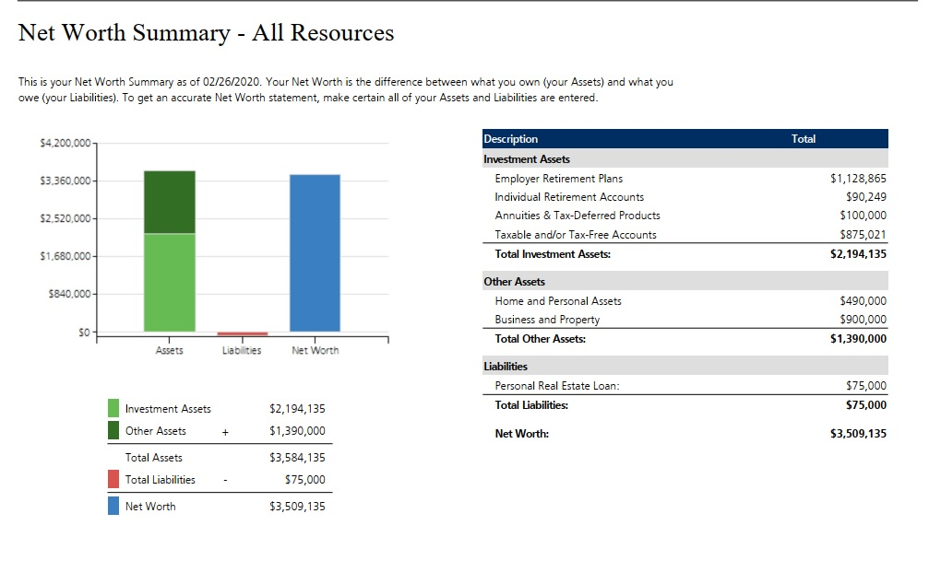
The investment profile is hypothetical, and the asset allocations are presented only as examples and are not intended as investment advice. Please consult with your financial advisor if you have questions about these examples and how they relate to your own financial situation.

The following report is an example of where you are, and where we recommend you to be. It helps to determine if your current strategy and plan are in tune with your retirement goals.

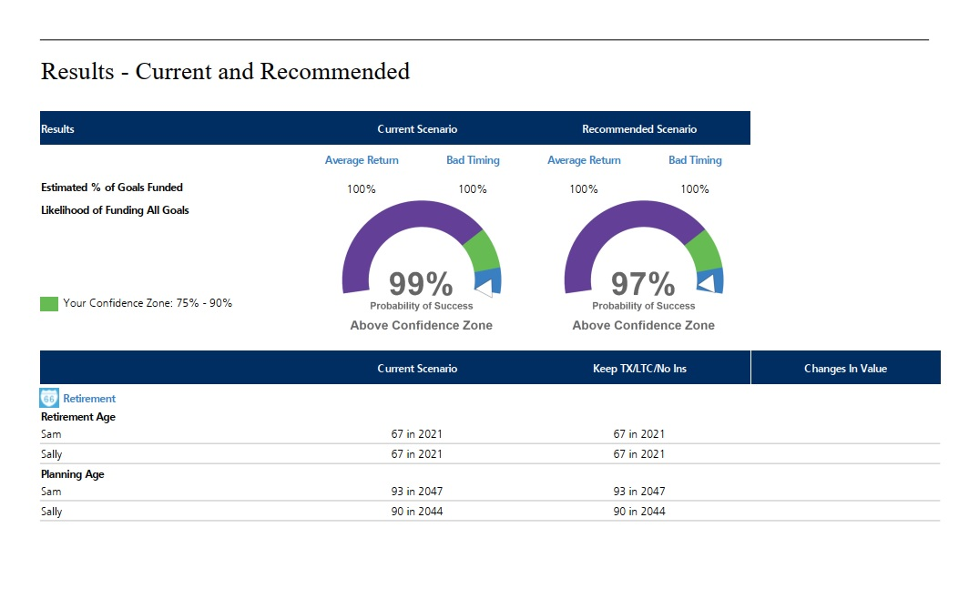

The investment profile is hypothetical, and the asset allocations are presented only as examples and are not intended as investment advice. Please consult with your financial advisor if you have questions about these examples and how they relate to your own financial situation.

Planning for Retirement Checklist

General Information
- Gather your personal information
  - Age __________ and age of spouse/partner __________
  - Number of children (and other dependents) and their children __________

- Has financial situation been assessed?
  - Annual income (pretax and after-tax) __________________________________________
  - Total annual expenses ______________________________________________________
  - Total assets and savings to date _______________________________________________
  - Total retirement savings to date ______________________________________________
  - Total liabilities to date ______________________________________________________
  - Total yearly contributions to 401(k)s and other employer-sponsored plans_____________
  - Total yearly contributions to IRAs (Roth or Traditional) ___________________________
  - Total yearly contributions to other retirement savings vehicles ______________________
  - Health insurance coverage for each spouse
  - Long-term care insurance coverage for each spouse
  - Life insurance coverage for each spouse
  - Disability insurance coverage for each spouse
  - Wills, beneficiary designations, and other estate planning information

Determining Retirement Income Needs
- Has your retirement age been determined?

- Has life expectancy been estimated in order to project how long retirement will last?

- Have annual retirement expenses been estimated? A great idea is to take the budget worksheet and pretend you are retired today and what your expenses would be.
  - Food, clothing, housing
  - Insurance
  - Health care
  - Travel and recreation
  - Other

- Has expected annual retirement income been estimated?
  - Social Security
  - Pensions
  - Savings and investments
  - Job earnings
  - Other

Investment Planning
- Have the appropriate investments for IRAs and employer-sponsored plans been selected?

- Has someone been designated to monitor those investments for performance and make changes when appropriate?

- Is there an investment portfolio that is designed to build wealth and achieve goals other than retirement?

- Has the impact of taxes been taken into account in assembling an investment portfolio?

- Have expectations been established for how the retirement portfolio and other investments may perform over the long term?

- Is some degree of investment risk acceptable?

- Has an anticipated annual rate of withdrawal from the portfolio after retirement been established?

Insurance Planning
- Will adequate health insurance be available to meet potentially high health-care costs during retirement?

- Have long-term care insurance and other strategies been considered in case long-term care is needed during retirement?

- Have other insurance needs during retirement been considered?
  - Life
  - Auto and homeowners
  - Liability
  - Other

Estate Planning
- Who are your beneficiaries?
  - Employer-sponsored plans __________________________________________________
  - IRAs ____________________________________________________________________
  - Annuities ________________________________________________________________
  - Life Insurance ____________________________________________________________
  - Other: ___________________________________________________________________

- Have valid wills been executed, including durable power of attorney and advanced medical directives?

- Have other estate planning tools and strategies been considered?
  - Trusts
  - Gifting assets
  - Other

Retirement Estimator

 |  | Example | You
1 | Your current income | $50,000
2 | Multiply this amount by .80. This is an estimated annual income in retirement, in today’s dollars, based on 80% of your current income. (Or enter a different amount, if you choose. Most experts suggest 70% to 100% of your current annual income.) | $40,000
3 | Estimated yearly income from Social Security – visit www.socialsecurity.gov to estimate your income | $20,000
4 | Other sources of income (pension, real estate income, etc) | $0
5 | Add lines 3 and 4. This is your estimated annual income, in today’s dollars from other sources | $20,000
6 | Subtract line 5 from line 2. This is your estimated income gap, which you will need to make up from your retirement savings | $20,000
7 | How many years until your retire? | 20 years
8 | Find the corresponding factor from Table A below and enter it here | 1.81
9 | Multiply line 6 by line 8. This is the amount that your savings will need to generate in year one of your retirement | $36,200
10 | How long do you expect your retirement to last? | 25 years
11 | Find the corresponding number from Table B below and enter it here | 22.32
12 | Multiply line 9 by line 11. This is the target amount you may need to accumulate by the time you retire | $807,984

Table A
Years until retirement | 5 | 10 | 15 | 20 | 25 | 30 | 35 | 40
Factor | 1.16 | 1.34 | 1.56 | 1.81 | 2.09 | 2.43 | 2.81 | 3.26

Table B
Years in retirement | 5 | 10 | 15 | 20 | 25 | 30 | 35 | 40
Factor | 4.90 | 9.58 | 14.03 | 18.27 | 22.32 | 26.17 | 29384 | 33.34

This worksheet assumes that inflation rises at an average of 3% per year both before and during retirement. It also assumes that your investments grow at an average of 6% per year before retirement and 4% per year during retirement. Such assumptions are hypothetical and cannot be guaranteed.

This worksheet is not meant as advice, but as a way to provide a general estimate for illustrative purposes. Your specific goal should take into consideration your total family income, your current and expected assets, and other unique circumstances.

Five Retirement Savings Tips to Help Avoid Regret

According to a recent TIAA-CREF Ready to Retire survey, “…more than half of people approaching retirement (52%) say they wish they had started saving for the future sooner” Some key findings from the survey also included:

- 47% of respondents wish they had saved more of their paychecks for retirement and 34 percent wished they invested their savings more aggressively.
- 45% of participants ages 55-64 said that financial readiness was the most important factor in determining when they will retire, but only 35 percent say they saved in an IRA or have met with a financial advisor.
- 68% of those approaching retirement said they are not prepared for what is to come.

Here are five tips to help you avoid regret when it comes to saving for your retirement.

- Start Early
If you are currently working, make sure you are enrolled in your employer’s 401(k), 403(b) or whatever type of retirement plan they offer and contribute as much as you can. Make sure that you are at least contributing to the point of a match.

- Increase your contributions
The maximum 401(k) contribution limits for 2021 are $19,500, if you are over 50 the max is $26,000. Try to contribute a little more each year.

- Start a self-employed retirement plan
If you ever become self-employed, start a plan such as a SEP or Solo 401(k) plan as it is still important that you save for retirement.

- Contribute to an IRA
Anyone can contribute to an IRA. Traditional IRAs are subject to income limits as far as the ability to make pre-tax contributions, but anyone can contribute on an after-tax basis with no income limits. All investment gains grow tax-deferred. Roth IRAs can also be a good alternative; again there are income ceilings that can limit your ability to contribute. For 2021, you can contribute $6,000 and if you are over 50 years of age, you can contribute $7,000.

- Don’t ignore old retirement accounts
It is not uncommon for people to have worked for five or more employers during their career. It is very important that you make an affirmative decision as to what you with to do with your old 401(k) or other retirement account when you leave that employer. Leave it where it is, roll it to an IRA, or to your new employer’s plan (if allowed) or cash out. Don’t ignore this money.

Debt and Cash Flow
Budgeting. That dreaded word. Most of the American population does not have a budget. Budgeting is not fun but something that we believe is extremely important. When you have a budget, you spend money on the things you truly need and want. You spend money consciously and truly where you want your money to go.

Do you often wonder where all your money goes? Having a budget and tracking where your money goes can be very beneficial to achieving your financial goals. We often do not realize how all of the little things add up. A coffee here and a dinner there all add up and take away from money you could be saving. Have you ever had a $20, $50, or $100 bill in your pocket and a couple days (or hours) later it is gone and you don’t have anything to show for it? Tracking what you spend for a month or couple of weeks could be an eye-opening experience. You might see some things that you don’t necessarily need and could eliminate from your monthly expenses. All those little amounts combined could be saved and put toward achieving your financial goals for the future. So, this month try to track your spending and see if you need everything you buy.

There is truly a difference between a want and a need. You want to really stop and ponder before you buy something and determine if it is a want or a need. We have a budget worksheet that we have developed over the years to help you with your budget. The easiest way is to take this budget worksheet and to start from today forward and truly write down everything you spend.

On the following pages, we have developed a budget worksheet for you. The best way to develop a budget to track all your expenses for the current month. Set a timer for 15 minutes and work on it for 15 minutes at a time. When it is complete, send it to us and we can give you some ideas as well as to where you can cut back on your expenses. Completing this budget worksheet is the first step in awareness of where you are spending money and you may be able to find areas to cut back.

Budget Worksheet

Expenses:
Living Expenses:
Mortgage/Rent: _______________
Heloc: _______________
2nd Property: _______________
Investment Prop: _______________
Home Insurance: _______________
Property Taxes: _______________
Assessment: _______________
Condo Fees: _______________
Dining Out: _______________
Lunch at Work: _______________
Groceries: _______________
Bedding/Linens: _______________
Pet Expenses: _______________
Postage: _______________
______________ _______________
______________ _______________

Home Maintenance Expenses:
Furniture: _______________
Interior Repairs: _______________
Home Supplies: _______________
House Cleaning: ______________
Decorating: _______________
Lawn Mowing: _______________
Landscaper: _______________
Snow Blowing: _______________
Furnace Filters: _______________
Garbage: _______________
Security System: _______________
Water Softener Salt: _______________
Tree Trimming: _______________
Spring/Fall Cleanup: _______________
House Painting: _______________
Gardening: _______________
Plumber: _______________
Room Maintenance: _______________
Irrigation: _______________
Pest Maintenance: _______________
Water System: _______________
______________ _______________
______________ _______________

Personal Expenses:
Clothing: _______________
Hosiery: _______________
Shoes: _______________
Haircuts: _______________
Beauty Salon: _______________
Jewelry: _______________
Beauty Supplies: _______________
Massage: _______________
Manicure/Pedicure: _______________
Alterations/Repairs: _______________
Dry Cleaning: _______________
Spousal Maintenance: _______________
Personal Trainer: _______________
______________ _______________
______________ _______________

Utilities:
Electricity: _______________
Gas: _______________
Water: _______________
Phone: _______________
Cable TV: _______________
Cell Phone: _______________
Long Distance: _______________
Pager: _______________
Voicemail: _______________
DSL/Internet: _______________
Sewer/Septic: _______________
Firewood: _______________
______________ _______________
______________ _______________

Transportation:
Car Loan/Lease: _______________
Gas: _______________
Car Insurance: _______________
Vehicle Tabs: _______________
Car Washes: _______________
Oil Changes: _______________
Parking: _______________
Maintenance: _______________
Repairs: _______________
Bus Pass: _______________
Bikes: _______________
Car Savings: _______________
______________ _______________
______________ _______________
Medical:
Doctor Visits: _______________
Health Insurance: _______________
Eyeglasses/contacts: _______________
Dental: _______________
Medications: _______________
Medicare Supplements: _______________
LTC Insurance: _______________
Life Insurance: _______________
Disability Insurance: _______________
Vitamins: _______________
Non-Reimbursable: _______________
______________ _______________
______________ _______________

Recreation:
Hobbies: _______________
Relaxation: _______________
Sport Activities: _______________
Vacation: _______________
Theatre: _______________
Sports Events: _______________
Movies: _______________
Entertainment: _______________
Home Entertaining: _______________
Boat Expenses: _______________
Boat Insurance: _______________
Watercraft Expenses: _______________
Watercraft Insurance: _______________
Pool Expenses: _______________

Memberships:
AAA: _______________
Golf Club: _______________
Country Club: _______________
Sam’s Club: _______________
Costco: _______________
Golf League: _______________
Bowling League: _______________
Other Leagues: _______________
Health/Fitness Club: _______________
Fish/Hunt Licenses: _______________
Union Dues: _______________
______________ _______________
______________ _______________

Debit/Credit Cards:
______________ _______________
______________ _______________
______________ _______________
______________ _______________
______________ _______________

Savings:
401k/457/403b: _______________
Roth/Traditional IRA: _______________
Deferred Comp: _______________
Liquid Money: _______________
VUL Insurance: _______________
Annuity: _______________
Spending Money: _______________
529/Ed IRA/UTMA: _______________
______________ _______________
______________ _______________

Miscellaneous:
School Expenses: _______________
Paper/copies: _______________
Laundry: _______________
Cards/Gifts: _______________
Donations: _______________
Travel: _______________
Cigarettes: _______________
Alcohol: _______________
Magazines: _______________
Books: _______________
Accountant Fees: _______________
Financial Fees: _______________
Attorney Fees: _______________
Income Taxes: _______________
Safe Deposit Box: _______________
Newspapers: _______________
Agent Fees: _______________
Promotion Fees: _______________
______________ _______________
______________ _______________

Kids Expenses:
Clothing: _______________
Shoes: _______________
Food: _______________
Transportation: _______________
School Expenses: _______________
Cell Phone: _______________
Lunch Money: _______________
Personal Supplies: _______________
Haircuts: _______________
Babysitter: _______________
Nanny: _______________
Child Support: _______________
Day Care: _______________
Diapers: _______________
Diaper Service: _______________
Medical: _______________
Summer Camp: _______________
Activities: _______________
Lessons: _______________
Parenting Consultant: _______________
Supervision: _______________
Allowance: _______________
______________ _______________
______________ _______________

TOTALS:
Total Income: ______________
Total Expenses: ______________
Income minus Expenses: ______________

Nearing Retirement Checklist
1 Year Before Retirement
- Have other major financial goals been funded or achieved?
  - Pay off home mortgage
  - Fund children’s education
  - Buy retirement home
  - Other: ___________________________________________________________________

- Have annual retirement expenses been estimated?
  - Food, clothing, housing
  - Insurance
  - Health care
  - Travel and recreation
  - Other: ___________________________________________________________________

- Has expected annual income been estimated, and will that income be sufficient to meet retirement needs?
  - Social Security
  - Pensions
  - Savings and investments
  - Job earnings
  - Other: ___________________________________________________________________

- If not, are there steps that can be taken to bridge the gap?
  - Work part-time
  - Cut expenses
  - Set more modest goals
  - Delay retirement
  - Other: ___________________________________________________________________

- Is a 401(k) or other employer-sponsored retirement plan funded?

6 Months Before Retirement
- Now that retirement is near, have plans been made to change how the retirement portfolio and other assets are invested?

- Will the client/advisor monitor the retirement portfolio and other investments throughout retirement and make changes when appropriate?

- Have expectations been established for how the retirement portfolio and other investments may perform in the coming years?

- Is some degree of investment risk acceptable?

- Has a distribution strategy been discussed/developed?

- Have you applied for Social Security benefits?

- If under age 65, will adequate health insurance be available until Medicare eligibility is established?

- If 65 or older, has a Medigap or other health policy been purchased to supplement Medicare, or is employer-sponsored coverage available?

- Is there long-term care insurance, or have this and other strategies been considered to protect against the cost of nursing home care?

- Have life insurance needs been revisited?

- Have other types of insurance coverage been reviewed?
  - Auto and homeowners
  - Disability
  - Liability
  - Other: ___________________________________________________________________

1 Month Before Retirement
- Will beneficiary designations be reviewed periodically?
  - Employer-sponsored plans
  - IRAs
  - Annuities
  - Life Insurance
  - Other: ___________________________________________________________________

- Has will been reviewed/updated?

- Is there a durable power of attorney or health-care directive?

- Have other estate planning tools and strategies been considered?
  - Trusts
  - Gifting assets
  - Other

- Prepare for any withdrawals from assets. How much is needed and from which account?

Day of Retirement
- Make planned changes to employer sponsored retirement plan (withdrawal, rolling over, etc.)
- ENJOY!

Income in Retirement
Thinking about retiring can be a scary thought. Here you have worked and worked and worked for all these years and have saved and saved and saved and now you want to retire and start taking money out of your accounts. This can be intimidating. Confusing. Tricky. You are going from one stage of life to the next. You are moving from accumulation phase to distribution phase.

There are many decisions to make when you start to think about retiring. When should you collect Social Security? When should you start taking money from your IRAs? What do you do about health insurance?
There are many important things to consider when you are looking at living off everything you have saved and invested years for.

Most people want to wait until full retirement age to begin collecting Social Security so they can get the full amount. However there are over 400 different ways to collect Social Security. When you get close to 60 years old is when you should start looking at all your options and figure out which one makes the most sense to you. You can get a copy of your Social Security statements and we can do a Social Security analysis for you.

The other important thing to remember is health care. The main reason people do not retire early is because of health insurance. Medicare does not start until you reach 65. So if you retire at 62, what are you going to do about health insurance? This is one of the main reasons people delay retirement because of the cost of healthcare and health insurance.

The other important age to remember is 59 ½ and 72. In any pre-tax retirement account such as your 401(k) or Traditional IRA, if you are under the age of 59 ½ and start taking money out before you are 59 ½ you will have to pay an additional 10% penalty. This is in addition to the state and federal income tax on the money that you took out. So pretty much almost half of what you take out will go to taxes and penalties. 72 is the age where you need to take RMD’s. These are Required Minimum Distributions. When you turn 72 you are forced to take money out of these accounts and pay income tax on the money you are taking out. If you take the wrong RMD amount there is also a high penalty assessed from the IRS.

Getting ready to take money out of your IRA’s or 401(k) is a psychological shift. It is hard to think that one day you are contributing money to your IRA and 401(k) and then all of a sudden you are pulling it out. One way that can help with this change is to have a plan. You want to look at the numbers. For example, if you have accumulated $1,000,000 for your retirement, the safe withdrawal rate is between 3-4%, which means you can take out $30,000-$40,000 per year of income without tapping into your principal (the $1,000,000 that you invested).

These are just a few of the things to consider as you get closer to retirement. Going from the accumulation phase to the distribution phase can be scary but it doesn’t have to be. You worked hard, saved hard and now can use the money you invested for years to help you enjoy your retirement.

Conclusion

Congratulations! Planning for your retirement is big step for your financial future. We highly encourage you to keep on this path and re-evaluate your budget, cash flow and financial plan as your situation changes.

At Prosperwell Financial, we believe that life is not just about money, but instead it is about doing things that truly make you happy and living your life to the fullest. Our mission is to coach, mentor and inspire you to achieve financial independence and happiness. We would love the opportunity to work with you to help you achieve your goals, work towards what makes you happy and help you live your very best life.

If you are interested in meeting with one of our Wealth Advisors to help you get started on investing or to get a second opinion on your investments, we would be happy to offer you a complimentary consultation. You can call our office at 763-231-9510 to schedule.

